
CS 319 - Object-Oriented Software Engineering
Analysis Report
Dave Davesson
Group 6
Ali Atlı – 21302442
Berk Türk – 21302570
Sefa Gündoğdu - 21301794
Burak Özmen – 21200918

Introduction
In our project, we are going to implement a game called Dave Davesson. Dave Davesson is a Java based platform game that is inspired by the old fashioned MSDOS game Dangerous Dave. Like the original, the main goal is to find the key to open the door and advance into the next level.

Link to Dangerous Dave game: http://playdosgamesonline.com/dangerous-dave.html

Apart from the original, there will be some different features like multiplayer mode, different weapon types and various maps. In multiplayer mode, two players will start the game from opposite sides of the map and the focus is to eliminate the opposing player with the guns given by the game.

Dangerous Dave will mainly focused on Player-to-Object, but there will be some Object-to-Object focuses, for example obtaining a key to open the doors, killing enemies with the guns’ projectiles. Lastly, the game will be played with a keyboard for both players.

Overview
Dave Davesson is a modern day clone of the original Dangerous Dave platform game, with a few additions that will make the game more fun. The original version of the game featured single-player mode where the players would find the cup that is in an uncanny spot in the map, then would go on to open the door to a new map, while also collecting the goods (diamonds, lives, guns etc) to further increase the propitiousness of the player. This part of the game persists in this version too, with changes in the graphics.
The new version that we will add is the multiplayer mode, where the goal of the game is to kill the opponent with the guns that are placed on the map. The players have health points and the guns have different damage points and different recoil times to allow players to develop distinct play styles.

Gameplay
The game is played using arrow and ‘W’, ‘A’, ‘S’, ‘D’ keys on the keyboard. More specifically, the single-player mode will allow users to play with either of them, whereas the multi-player version will assign at the beginning of the game the controller depending of the spawn position of the Dave, the right most Dave will be controlled by arrow keys and vice versa. The Daves will be distinguished by their colors to ease visual understanding of the game.

Maps
The maps in the single-player mode are levelled with respect to their difficulty in the game play. The first map will be very straightforward to pass, a player will be able to pass this map just jumping on the bricks without being exposed to any dangerous elements. As the levels proceed the game will introduce different obstacles ranging from fire, water, bushes to monsters that will cause the loss of life. Some maps are wide and therefore cannot be visually examined at once. This problem will be solved by introducing a border that is positioned close to the continuation of the map whose crossing will bring the remaining part of the map.
The multi-player maps will not have cups or keys but obstacles that will enable users to cover from bursts of guns, moreover, they will feature fire, water and maybe even monsters.
The maps will contain guns and health stations to restore health. The multi-player maps will be designed to fit in to a single screen, so as not to further complicate the matter.

Dave's
Dave's will have three lives at the beginning of the every map. They will be represented by different graphics in case of jumping, running and gunning. They will have distinct colors for multi-player version. They are the single elements that can be controlled by the players. They are vulnerable to fire, water and bushes. They will be able to jump from bricks that are hung on the map and collect items upon positioning themselves on the items. There will only be one type of brick, as we see no reason to change the functionality of the bricks. The limit for carrying items non-existant except for guns. The maximum number of lives will not exceed three and a hundred health point for single-player and multi-player modes respectively. The speed of jumps and jogs are constant at all times and can be arranged from the settings menu.

Gun Types
There will be three types of guns: sniper, shutgun and pistol.
Sniper: The most powerful weapon in the game. But it has one drawback, its long duration to reset. This gun will bring the opponent to a standstill in one shot. It will fire one bullet per shooting. We plan to hide it in a very hard place in the map.
Shutgun: It bursts three bullets per shooting, and one hit gives only 34 points of health damage. Recoil time is shorter than that of Sniper. The bullets are spread upon firing, so a close shut would suck all the life points of the enemy.
Pistol: The fastest of all guns. It requires five hits to kill the enemy. This gun will be abundant and relatively worthless.

All guns will have unlimited bullets.

3. Requirement Specification
3.1 Functional Requirements
-In the first view of the game there are 3 options.
*Play Game
*High Scores
*Settings and Help
Play Game: This is the option that player starts the game.
High Score: This is the option that player can see and track his/her high scores.
Settings and Help: This is the option that player can read the help that includes instructions about the game and change sound volume, name etc.
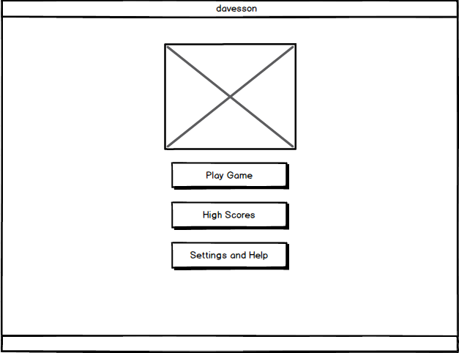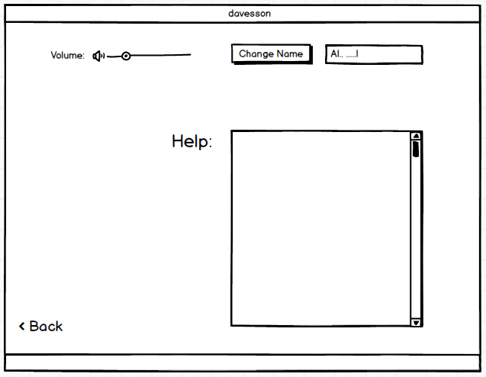
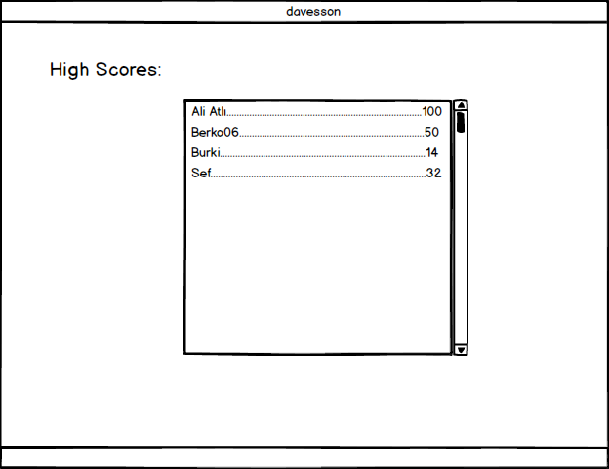

In addition to the play game option, It will provide new options to the user.
-Single Player
-Multiplayer
These options are important because game will prepare mouse keys, map, number of characters in the game, the objects of the game such as guns, armor, boss monsters based on these options.
If user choose single player, he/she will play the mandatory game which is the same as real Dave game. Namely, user can't choose guns, map, dave versions.
But if user choose multiplayer, he/she will play the game which was chosen by the user.
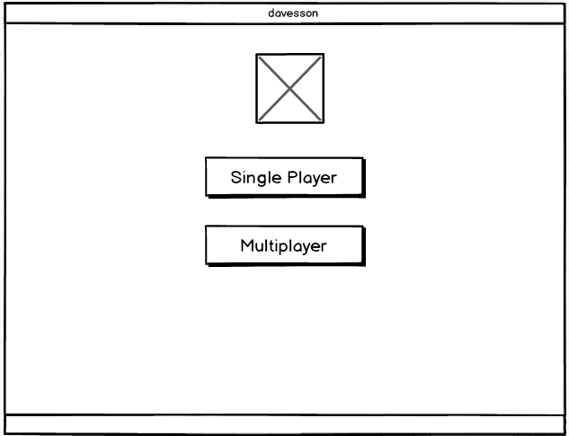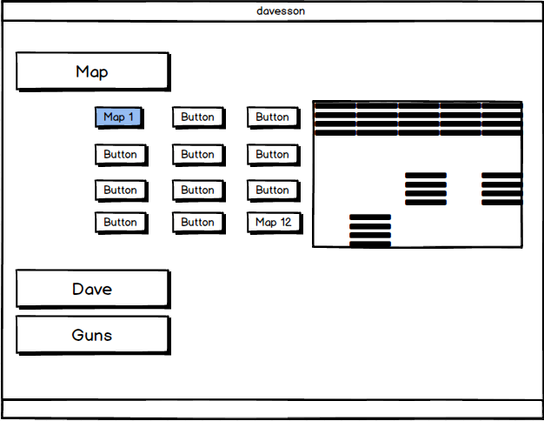
*(Kind of)

3.2 Non-Functional Requirements
-Firstly, the game performance is important so to make it as smooth as possible there will be different sound effects in the game and dynamic graphical effects like gun or fire effects.
-To make the game fluency, we have to make the graphical design using different technologies.
*So, the game should have low response time to user’s keyboard commands. This is an important feature for the fluency, and it will better the quality of the game.
-In multiplayer game, while two of Davesson family are fighting with each other, they will have different weapons with different fire rate and damage points. This feature will make this game more fun.
-The user will be able to save and load his/her game.

